**Project # 1**

**C++:**

**Course:** Programming Fundamental

**Course code:** CS-102

**Section: Bscs-23-B**

**Submitted to:** Dr. Zahid Iqbal

**Submitted by:**

Aiza Qaisar (23021519-074)

Rana Muhammad Fahad (23021519-174)

Yasir Iftikhar (23021519-086)



DEPARTMENT OF COMPUTER SCIENCE

**Library Management System**

#include <iostream>

#include<conio.h>

using namespace std;

void addbook();

void bookinfo();

void authorname();

void total();

void title();

void idnumber();

struct library

{

int idnumber;

string bookname;

string authorname;

string price;

string issuance;

}l[50];

int cont;

void display();

int main()

{

display();

while (true) {

cout << " " << endl;

cout << " -------------------------------- " << endl;

cout << " | press any key to run program | " << endl;

cout << " -------------------------------- " << endl;

_getch();

system("cls");

cout << "=================================================================" << endl;

cout << "Press 1 to add book information" << endl;

cout << "Press 2 to Display the book information" << endl;

cout << "Press 3 to list all books of given author " << endl;

cout << "Press 4 for to see how many books are there" << endl;

cout << "Press 5 for list the title of specific book " << endl;

cout << "press 6 for list the books for books ids " << endl;

cout << "press 7 for EXIT" << endl;

cout << "=================================================================" << endl << endl;

cout << " " << endl;

cout << " -------------------- " << endl;

cout << " | Enter your choice| " << endl;

cout << " -------------------- ";

int a;

cin >> a;

switch (a)

{

case 1:

addbook();

break;

case 2:

bookinfo();

break;

case 3:

authorname();

break;

case 4:

total();

break;

case 5:

title();

break;

case 6:

idnumber();

break;

case 7:

exit(0);

break;

default:

cout << "invalid entry" << endl;

}

}

return 0;

}

void display()

{

cout << " -----------------------------------------------------------------------------" << endl;

cout << " |~ ~|" << endl;

cout << " |~ ~|" << endl;

cout << " |~ ~|" << endl;

cout << " |~ WELCOME TO LAIBRARY MANAGEMAENT SYSTEM ~|" << endl;

cout << " |~ ~|" << endl;

cout << " |~ ~|" << endl;

cout << " |~ ~|" << endl;

cout << " ------------------------------------------------------------------------------" << endl;

}

void addbook()

{

cout << "Enter Book name =" << endl;

cin >> l[cont].bookname;

cout << "Enter author name =" << endl;

cin >> l[cont].authorname;

cout << "Enter Book idnumber =" << endl;

cin >> l[cont].idnumber;

cout << "Enter price of Book =" << endl;

cin >> l[cont].price;

cout << "Enter Book issued (Yes or No)" << endl;

cin >> l[cont].issuance;

cont++;

}

void bookinfo()

{

cout << " -----------------------------------------------------------" << endl;

cout << " | Display Book information |" << endl;

cout << " -----------------------------------------------------------" << endl;

for (int i = 0; i < cont; i++)

{

cout << " ----------------------------------------------------------" << endl;

cout << " | Id number of book= " << l[i].idnumber << endl;

cout << " | Title of book is = " << l[i].bookname << endl;

cout << " | Name of author is = " << l[i].authorname << endl;

cout << " | Price of book is " << l[i].price << endl;

cout << " | Boook issued (yes or no)" << l[i].issuance << endl;

cout << " ----------------------------------------------------------" << endl;

}

}

void authorname()

{

string a;

cout << "Enter author name =" << endl;

cin >> a;

for (int i = 0; i < cont; i++)

{

if (a == l[i].authorname)

{

cout << " ----------------------------------------------------------" << endl;

cout << " | Id number of book= " << l[i].idnumber << endl;

cout << " | Title of book is = " << l[i].bookname << endl;

cout << " | Name of author is = " << l[i].authorname << endl;

cout << " | Price of book is " << l[i].price << endl;

cout << " | Boook issued (yes or no)" << l[i].issuance << endl;

cout << " ----------------------------------------------------------" << endl;

}

else {

cout << "no book of this type" << endl;

}

}

}

void total()

{

cout << "number of books in libraray:" << endl;

cout << cont;

}

void title()

{

string a;

cout << "Enter title of book =" << endl;

cin >> a;

for (int i = 0; i < cont; i++)

{

if (a == l[i].bookname) {

cout << " ----------------------------------------------------------" << endl;

cout << " | Id number of book= " << l[i].idnumber << endl;

cout << " | Title of book is = " << l[i].bookname << endl;

cout << " | Name of author is = " << l[i].authorname << endl;

cout << " | Price of book is " << l[i].price << endl;

cout << " | Boook issued (yes or no)" << l[i].issuance << endl;

cout << " ----------------------------------------------------------" << endl;

}

else {

cout << "no book of this type" << endl;

}

}

}

void idnumber()

{

int a;

cout << "Enter id number of book =" << endl;

cin >> a;

for (int i = 0; i < cont; i++)

{

if (a == l[i].idnumber) {

cout << " ----------------------------------------------------------" << endl;

cout << " | Id number of book= " << l[i].idnumber << endl;

cout << " | Title of book is = " << l[i].bookname << endl;

cout << " | Name of author is = " << l[i].authorname << endl;

cout << " | Price of book is " << l[i].price << endl;

cout << " | Boook issued (yes or no)" << l[i].issuance << endl;

cout << " ----------------------------------------------------------" << endl;

}

else

{

cout << " no book of this id is availabe ";

}

}

}

**Output**

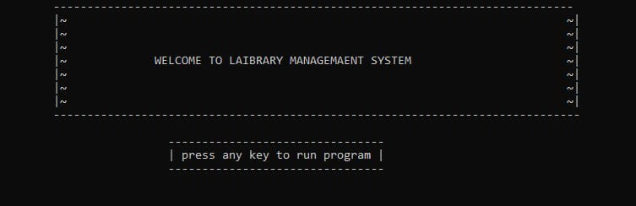

**When we press 1:**

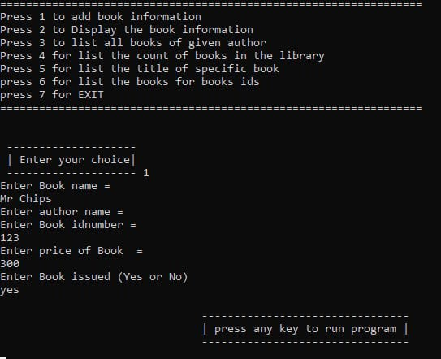

**When we press 2:**

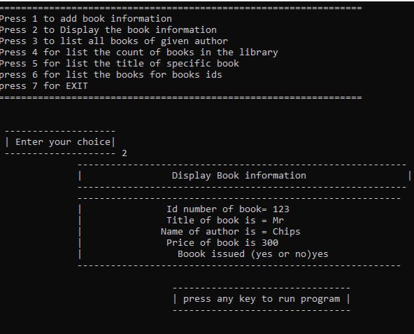

**When we press 3:**

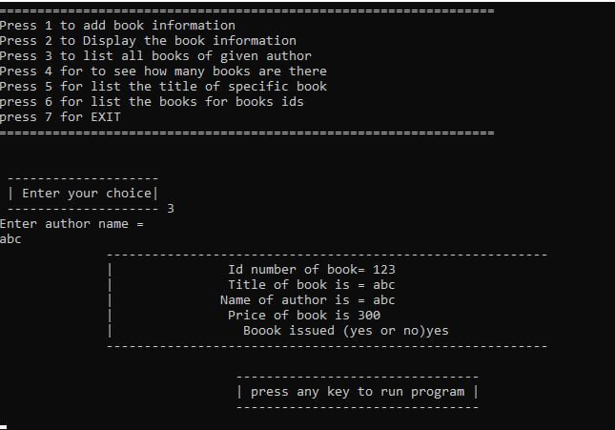

**When we press 4:**

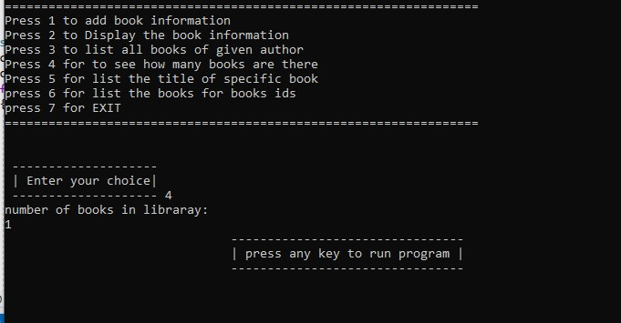

**When we press 5:**

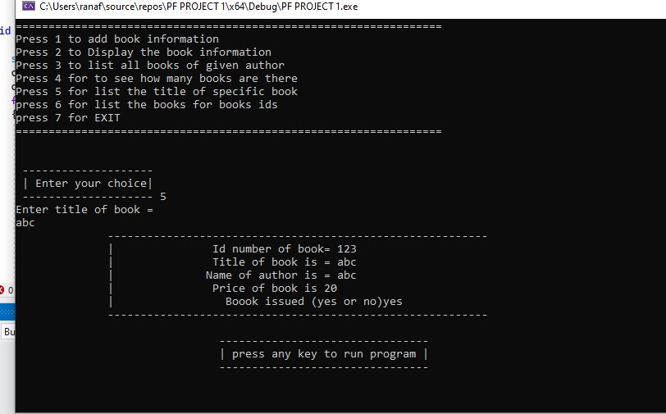

**When we press 6:**

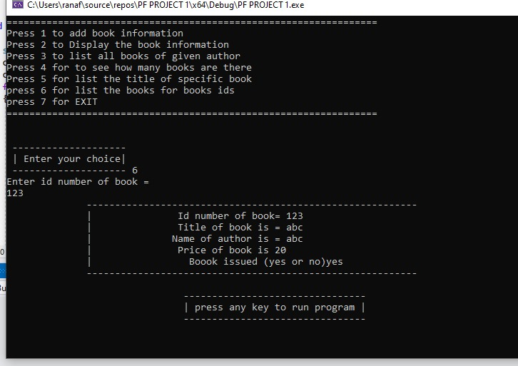

**When we press 7:**

